**SUCCESS STORY**

***ADOPTION OF FARM MECHANIZATION***

Name of the Farmer :- ***Nazeer Hussain S/O Sattar Mohd***

Village :- ***Dhalera***

District :- ***Poonch***

State :- ***Jammu & Kashmir***

Contact detail :- ***9697110730***

Farm size :- ***1.5 acres***

Water availability :- ***Lifting of water from Nallah by***

***using Irrigation Pump set***

***TECHNOLOGIES/FACILITIES OBTAINED***

The farmer was practicing traditional practice of using bullocks for ploughing of field for cultivating cereal crops as subsistence type of farming. The income from these crops was not sufficient to supplement his family livelihood in a sustainable manner. He was searching for other means of income generation from his land and resources available to him. He approached Deptt. of Agriculture Poonch for guidance and facilities. The Department of Agriculture provided Power Tiller to the farmer on 50% subsidy under SMAM during the year 2019-20. By the use of this machinery the farmer increases his area under vegetable & Garlic cultivation from 3 kanal to 8 kanal & earned an income of Rs. 2 lacs during this Rabi season.

The farmer in addition to cereals is now mainly growing vegetables like Garlic, Onion, Knol Khol, Raddish, Turnip, Spinach etc.

***FACTORS CONTRIBUTING TO SUCCESS***

Determination, Hard work and responses quickly to the Technological advice communicated to him time to time.

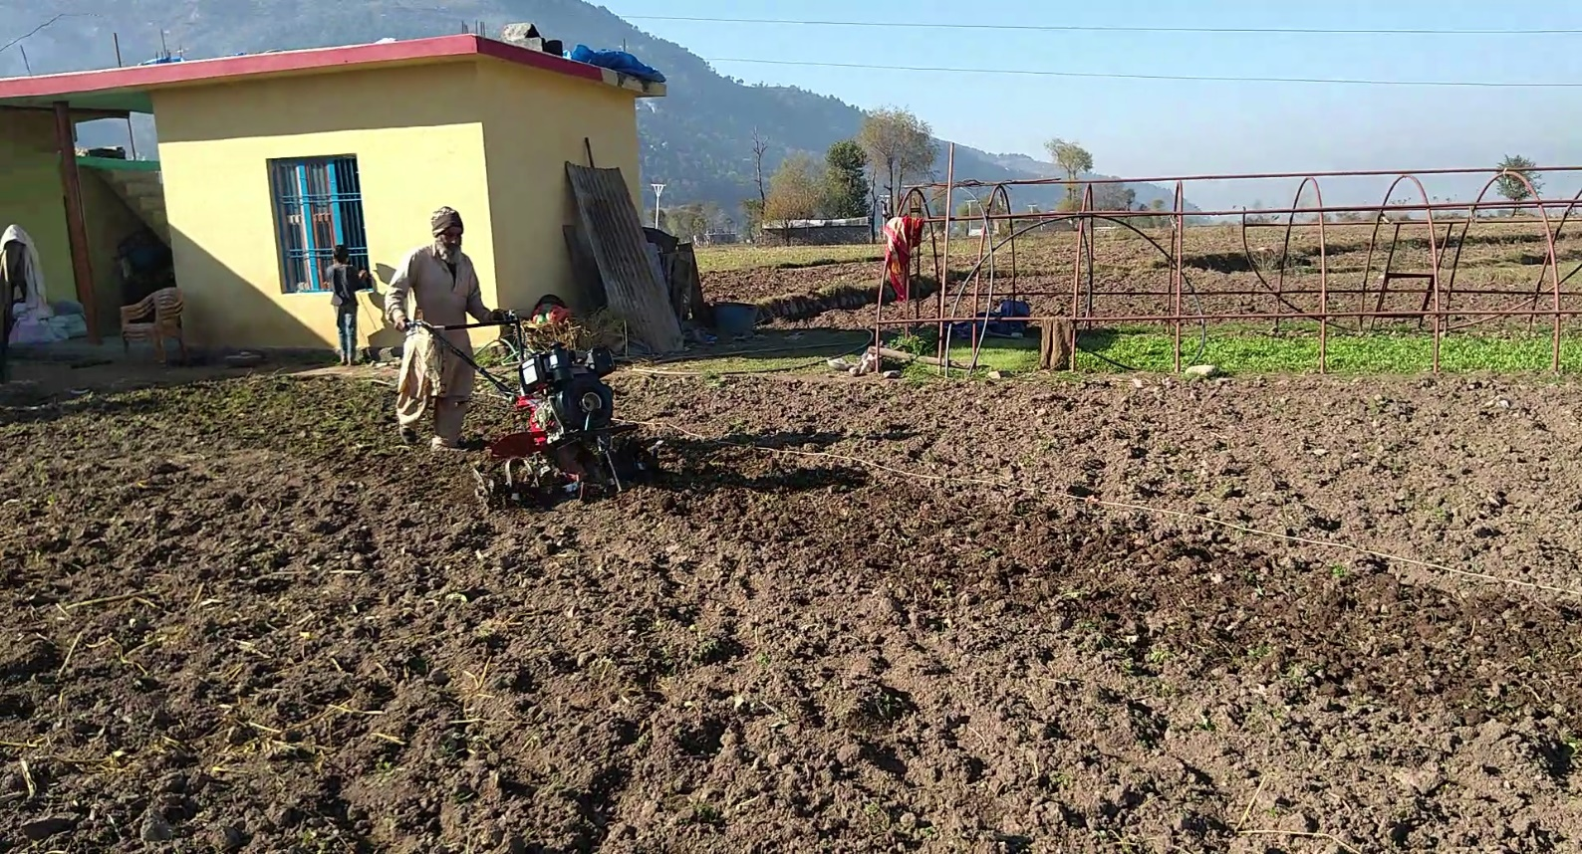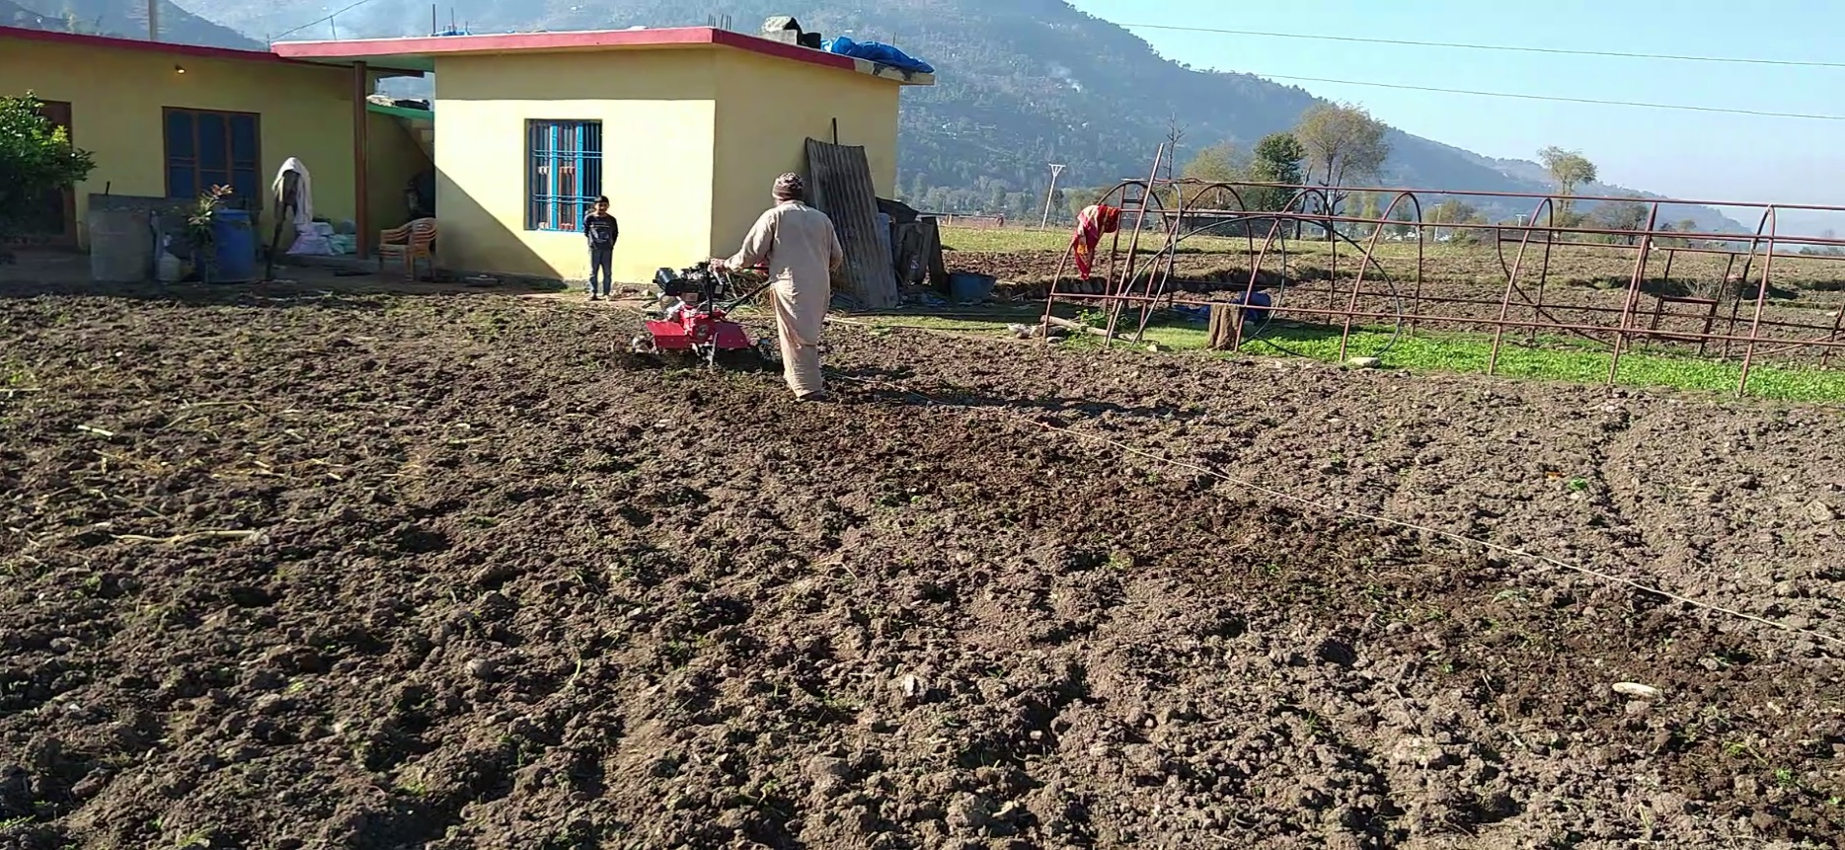

Farmer :- Nazir Hussain making functional use of Power Tiller provided by Chief Agriculture Department Poonch under subsidize rate

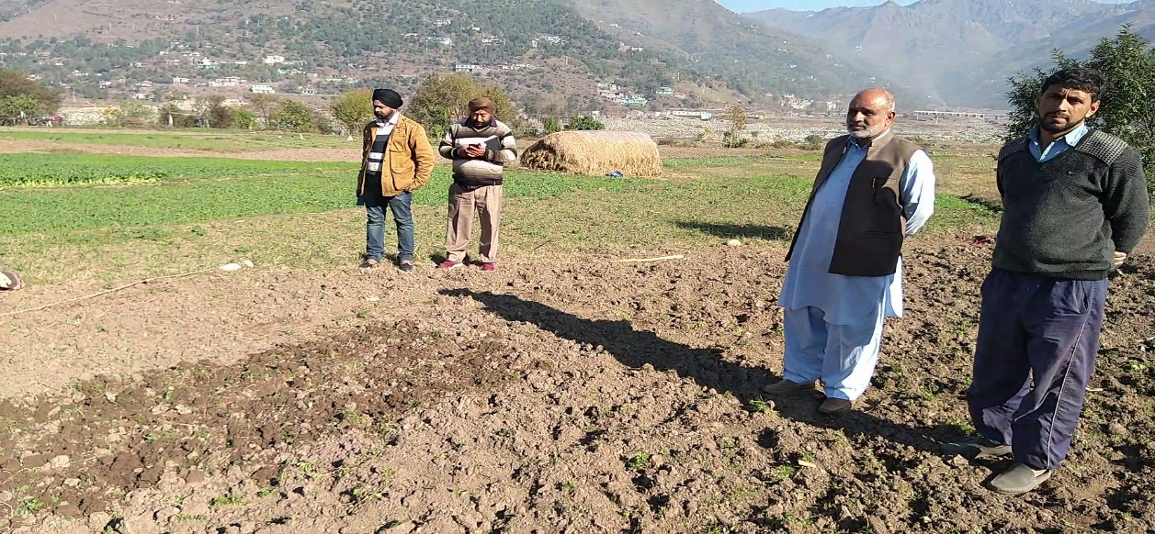

**Chief Agriculture Officer M. Y. Chowdhary** inspecting the land as well as briefing the mechanical use of the Power Tiller to the farmer along with his concerned officials.

